The GUI for the sample program
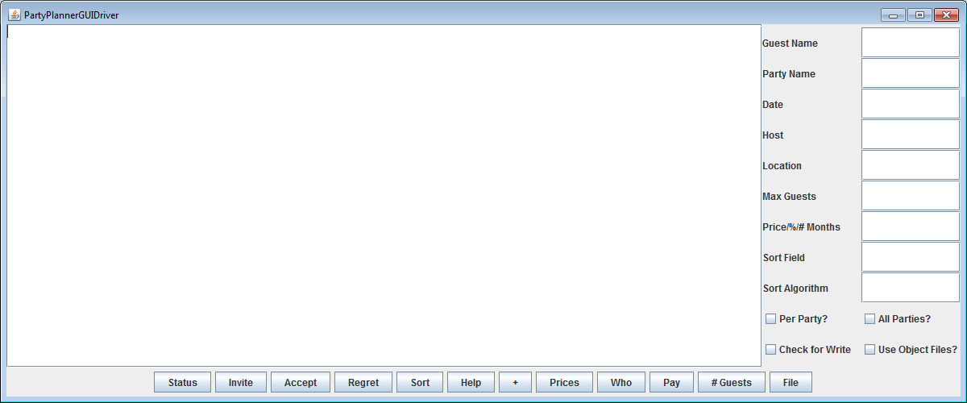

What happens when the Help button is clicked?

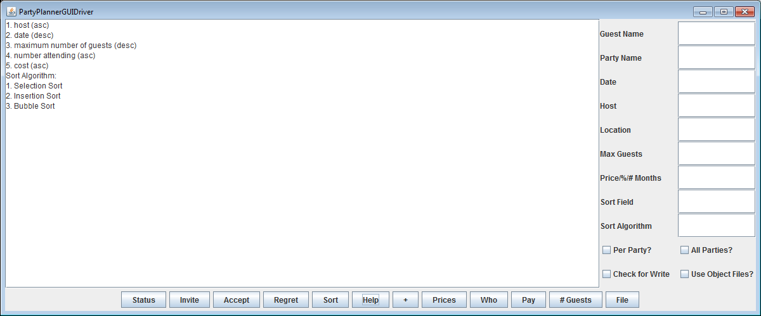

When the + (Add) button is clicked, the party name, date, host, location, max # of guests, and price are retrieved from the various text fields. Don’t forget to parse the max # of guests and price. The perParty information will be retrieved from the JCheckBox (isSelected method). Don’t forget to parse the numeric data (Integer.parseInt and Double.parseDouble methods).

When the Sort button is clicked, the sort field number and sort algorithm number are retrieved from the corresponding text fields. Don’t forget to parse the information.

When the Status button is clicked, the information about the PartyPlanner is displayed.

When the Invite button is clicked, the guest name will be retrieved from the appropriate text field. If the All Parties checkbox is checked, the planner will be asked to invite the guest to all the parties. Otherwise, the party name and date are retrieved, and an attempt will be made for the party planner to invite the guest to the party given by the name and date.

When the Accept button is clicked, the guest name, party name, and date are retrieved from the various text fields. An attempt will be made for the party planner to take the guest’s acceptance to the party given by the name and date.

Processing for the Regret button proceeds in a similar manner to Accept, except that the party planner will take the guest’s regrettal for the given party.

When the Prices button is clicked, the party name and date are retrieved from the various text fields. An attempt will be made to change the price for the given party by the percentage retrieved from the appropriate text field. Don’t forget to parse numeric data.

When the Who button is clicked, the party name and date are retrieved from the various text fields. An attempt will be made to find out who have been invited to the given party.

When the Pay button is clicked, the party name and date are retrieved from the various text fields. The number of months is retrieved from the appropriate text field. If there is no data, an attempt will be made to pay for the party in full. Otherwise, the data is parsed, and an attempt will be made to pay for the party with the given number of months.

When the # Guests button is clicked, the party name and date are retrieved from the various text fields. An attempt will be made to display the maximum # of guests, the number accepting, the number regretting, and the number unknown for the given party.

When the File button is clicked, if the “Check for Write” check box is selected, the store information will be written to an output file. If the check box is not selected, an input file will be processed, and a new party planner will be created from the contents of the input file. If the “Use Object Files?” check box is selected, the file will be treated as an object file; otherwise, the file will be treated as a text file.

The file format is the same format as in Program 2.

Clicking any button will result in appropriate output written to the large text area.

To quit the program, click in the x at the upper right hand corner of the window. You may provide a quit button if you wish.

